LOR 0.7A Resist Procedure:

1. Clean substrate with a solvent (ultrasonicate if desired), rinse with DI water
2. Dehydration bake 5 min at 200˚C
3. Spin HMDS @ 4000 rpm.
4. Select desired LOR thickness at 1.2 to 1.3 times more than the intended metallization
thickness, and determine necessary rpm according to:

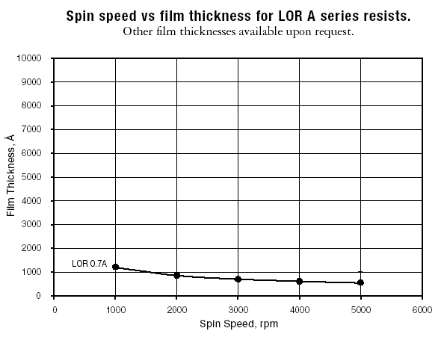
Spin speed should ideally be between 2500 and 4500 rpm. If you are well outside of this range, you may want to consider ordering a different series of LOR resist. See www.microchem.com for more information.

5. LOR spin 5s @ 400 rpm, 45s at determined rpm.
7. Determine Prebake time and temperature according to:

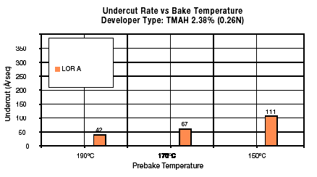
8. Prebake on hotplate for determined time and temperature

9. Spin on S1813 5 sec @ 900 rpm, 60 sec @ 4000 rpm
10. Second Prebake 60sec @ 90˚C
11. UV Expose 9sec
12. Puddle develop with LDD-26 developer for 15 sec.
13. Spin rinse with DI water 35 sec @ 400 rpm
14. Spin dry 60 sec @ 4000 rpm, with a burst of nitrogen gas in the center of the sample
15. Clean bowl and chuck with EBR PG, NOT acetone (may clog drainage system)
16. Metallization
17. Liftoff in a 2 bath system as follows:
- Bath 1: Ultrasonicate with Remover PG (~45˚C): 30 min
- Bath 2: Remover PG (60˚C): 30 min
- IPA rinse, DI water rinse, N₂ blow dry

